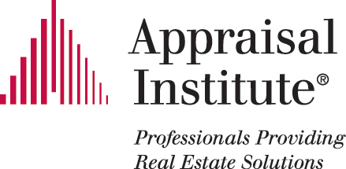

The CT Chapter of the Appraisal Institute
2014 SPONSORSHIP OPPORTUNITIES

Platinum Sponsorships, Benefits:

- Company name/Logo/link displayed on website home page (www.AI-CT.org)

- Company name/Logo displayed at Chapter Meetings

- Opportunity to display literature at a Chapter Meeting

- Opportunity to speak at a Chapter Meeting

- Company profile in Chapter newsletter

- Company name included in NEREJ articles (as available)

- Two tickets to Holiday Social/Installation

Gold Sponsorships, Benefits:

- Company name/Logo/link displayed on the Sponsor page on our website (www.AI-CT.org)

- Company name/Logo displayed at Chapter Meetings

- Company name included Chapter newsletter and NEREJ articles (as available)

Silver Sponsorships, Benefits:

- Company name/Log/ link displayed on the Sponsor page on our website (www.AI-CT.org)

- Company name displayed at Chapter Meetings

Sponsoring Company (or Individual):

__________________________________________________

Address: __________________________________________________
__________________________________________________

Sponsor Website: _____________________________________________

Contact Person: _____________________________________________
Title: _____________________________________________
Telephone: _______________________ Fax: _______________

Level of Sponsorship (please check one):

__________ $500, Platinum Sponsorship
__________ $250, Gold Sponsorship
__________ $100, Silver Sponsorship

I authorize The Appraisal Institute to link our website with the website of The Appraisal Institute.

Authorized by: __________________________________________________
Name and Title

Please return this form and your check made payable to The Appraisal Institute-CT Chapter as soon as possible. The Fiscal Year opportunity begins April 1, 2014.

The Appraisal Institute-CT Chapter
c/o Jacqueline Beauchaine
P.O. Box 509
Torrington, CT 06790
Telephone (860) 482-9992

